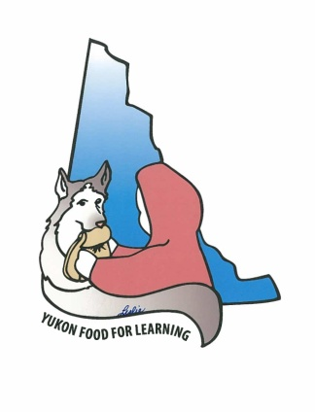Yukon Food for Learning Association

Grant Application - 2019/20 School Year

Section 1 General Information

School: _____________________________________________________________________

Contact Person: ____________________________ Phone: ____________________________

Email: ______________________________________________________________________

Section 2 Funding Requested for 2019/20

Balance on hand at end of 2018/19 School Year ______________

Presidents Choice Children’s Charity - amount requested ______________

Yukon Food for Learning Association – amount requested ______________

Other funding expected ______________

Total Funding – needed for 2019/20 ______________

If you are requesting an increase, please explain why you feel you need increased funding for this school year: ________________________________________________________________

__________________________________________________________________________
__________________________________________________________________________

Please ensure that either the originals or a copy of all receipts for food, etc. purchased with YFFLA funding have been provided.

Your grant will not be considered until those receipts are received

Section 3 Program Description

Number of students expected for the upcoming School Year: ___________________________

Number of Grades ____________________________________________

What type of school food program do you offer?

Meal Type | Yes/No | Number of Days per Week | Number of Students per Week

Breakfast

Lunch

AM Snack

PM Snack

Other information about your school food program: __________________________________

____________________________________________________________________________

____________________________________________________________________________

_____________________________________________________________________________

Please attach a sample weekly menu.

Section 4 Program Improvements

Are there any program changes you are planning for the upcoming school year?

______________________________________________________________________________

_____________________________________________________________________________

______________________________________________________________________________

Do you have any suggestions that would make the YFFLA granting process work better?

______________________________________________________________________________

Section 5 Agreement and Signatures

If a grant is provided, the recipient agrees to the following:

- The recipient will ensure the funded program embraces YFFLA’s Vision: Our vision is a Yukon where every student has access to nutritious healthy food while at school. YFFLA will support school-based nutrition programs and will encourage lifelong healthy eating programs.
- Upon request, the recipient will permit YFFLA or persons authorized by it to perform a review and/or evaluation of the activities for which the funds were granted.
- The recipient will abide by all other terms and conditions of the grant that may be imposed by YFFLA at the time of funding.
- The recipient will provide 2 reports on activities. The first on the period between the beginning of the school year and January 31 and the second for the period from February 1 to the end of the school year. The reports will include the following:
- Monthly Reports of the types of meals provided and the number of students served
- Financial Report
- Receipts – either the original or copies of receipts for food purchased

Section 7 Authorization and Execution

Authorization must be signed by the school principal or vice-principal.

The undersigned hereby certify that the above information is true and accurate.

__________________________________________ __________________________
Name Title

__________________________________________ ______________________________
Signature Date

Please return by Email to ykfoodforlearning@gmail.com or by mail to

Canada Post  YFFLA  Box 72,  Whitehorse, Yukon Y1A 5X9 | YG Internal Mail  YFFLA

