School: _______________________________________________________________

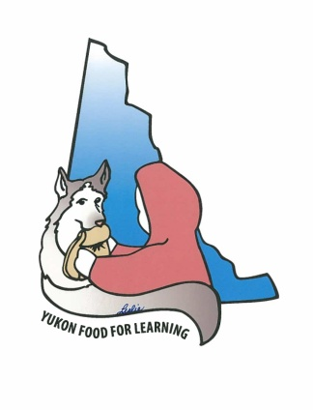
Program Type: |  | Breakfast |  | Lunch |  | Snack
Breakfasts/Lunches – must include a serving from at least three food groups from Canada’s Food Guide.
Snacks – must include a serving from at least two food groups and one must be from the Vegetables and Fruit food group.

Food Group | Examples |  | Monday | Tuesday | Wednesday | Thursday | Friday
Grain Products  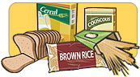 | Breakfast  Cheerios  1 cup | Snack  Whole grain crackers
Vegetables and Fruit  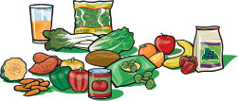 | Banana | Apple slices
Milk and Alternatives  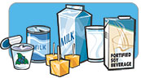 | Milk  1 cup | Cheese slice
Meat and Alternatives  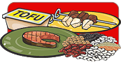 | Egg
Other Foods | Jam, Honey, Bacon

For more information: ykoodforlearning@gmail.com or call 867-633-5352

